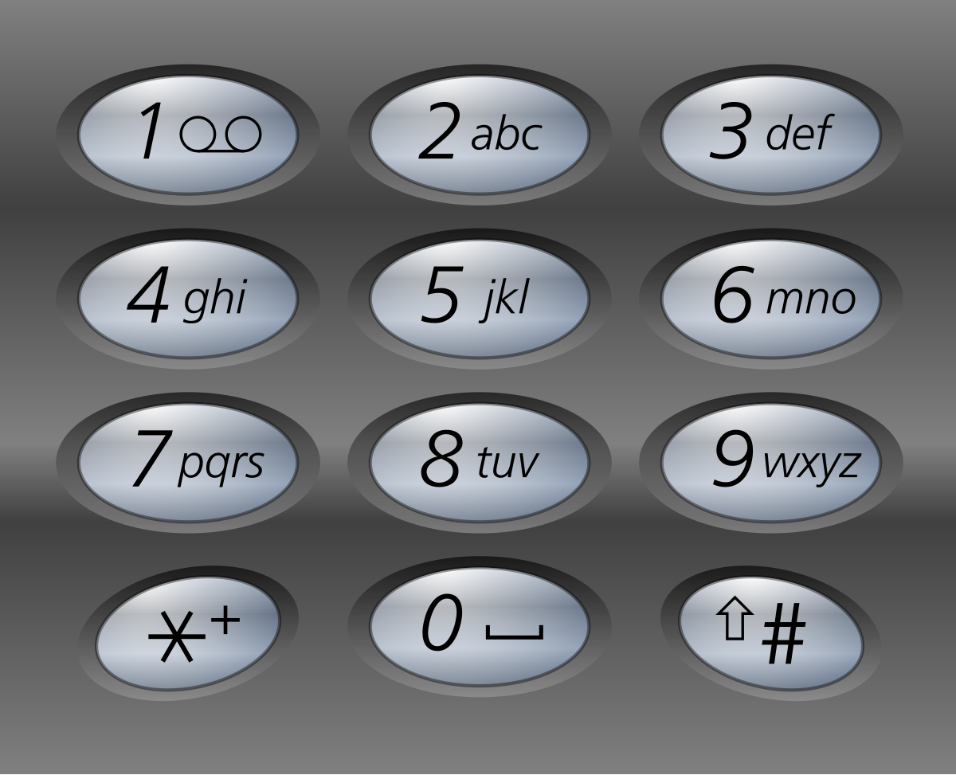

Functions:

1. Convert code to text
2. Convert text to code

Application Type :

Windows Form

Cases To Consider :

Case 1 : when alphabets of same number are sequential

Soln: if alphabets of same number are sequencial then user has to use a dot to separate out the alphabets.